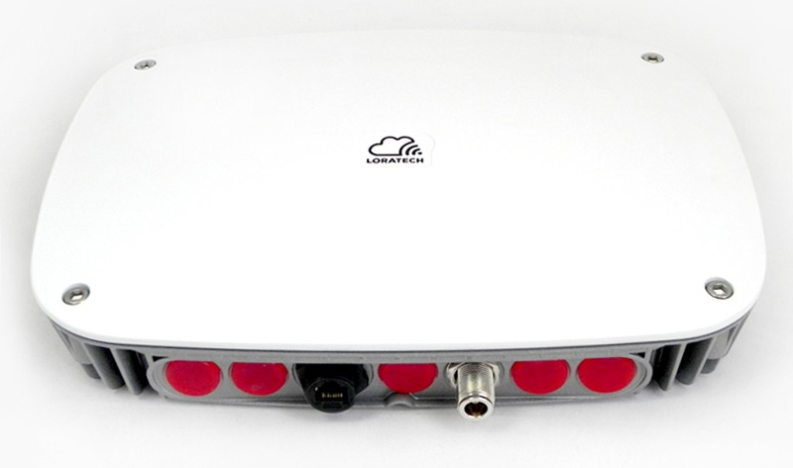
LORATECH
Outdoor Gateway
Product Datasheet
Ver. 2017-11-06-01

TECHNICAL DATA |  | PRODUCT DIMENSIONS
Material of body | Aluminium | 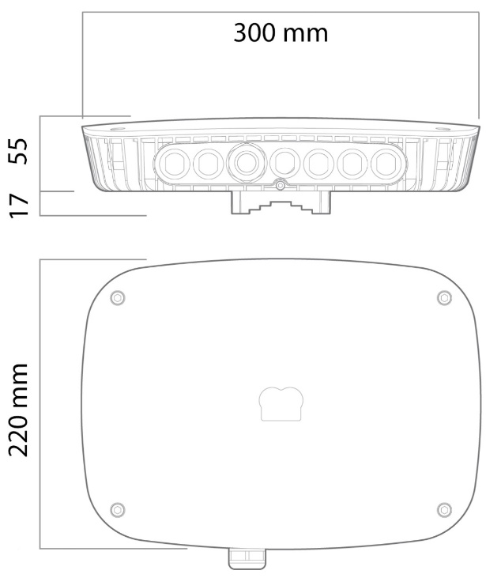
Weather Resistance | IP63
Weight | 1,2Kg
Operating Temperature | -20°C to +50°C
Mounting Diameter | 50 – 70mm
Input Voltage | Passive PoE, 12 – 48V
Max Power consumption | 7W
RF frequency | 868MHz (863 – 870MHz)
Sensitivity | Down to -138dBm
Output power level | Up to 20dBm
RF impedance | 50Ω
Connector ethernet | RJ45
Connector RF | N - female
Operation system | Debian/Raspbian
Default user | loratech
Default pass | loratech
Default IP (Fallback) | 192.168.1.77
Configuration Protocol | SSH / port 22

